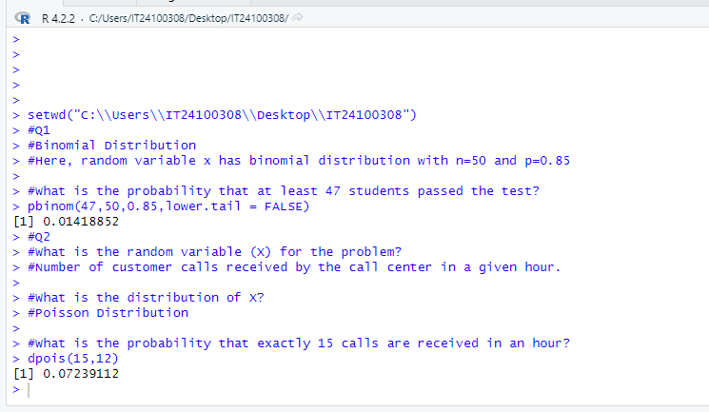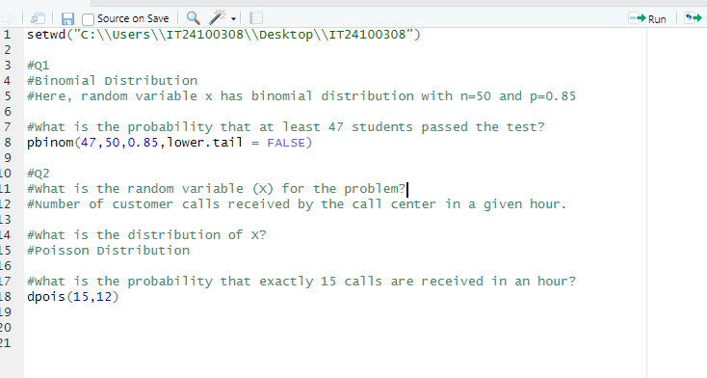Dissanayaka M.T.Y.S.K.

IT24100308

Lab 06